**Project Feasibility Report**

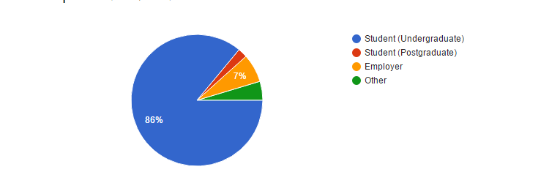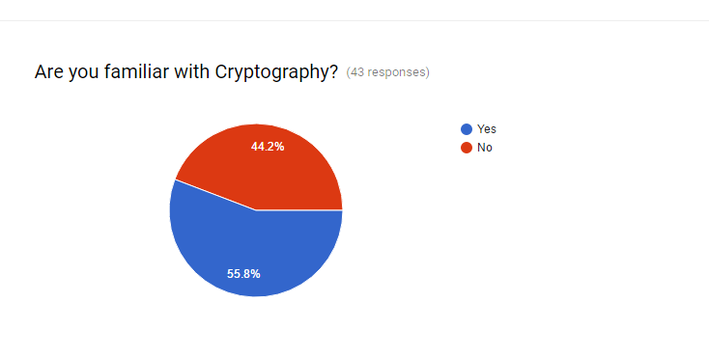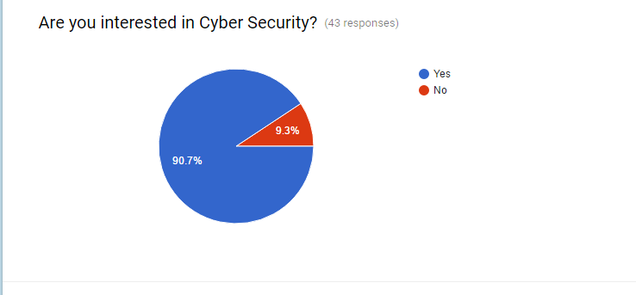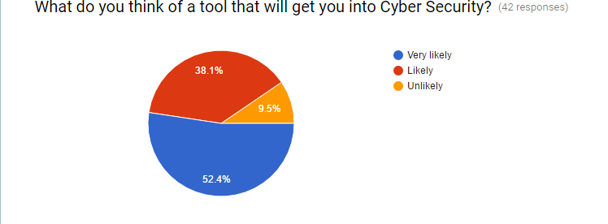

**2.1 Executive Summary**

In this growing era of technology the transmission of data is not safe in simple form. The data should in such a way that only authorized user can access the data not everybody. To transform this idea into reality we come up with the idea of sending files and text messages in an encrypted format using the encryption tool. This tool also helps us learn about the details of cryptography.

**2.2 Software Feasibility**

The Technology required for the implementation of this software is easily and freely available

In the listing of activity we, first need to implement the encryption algorithms and cope that with client server methodology.

**2.3 Time Feasibility**

The algorithms can be implemented and run in real time, so the other thing we have to do is to establish a client-server method in the software, so that the client can send the server files and messages in an encrypted format. We can understand that the project can be done in a limited time and could be run in a real time system so that the time can be easily managed for the system.

**2.4 The Market**

The market for this product is very large as compared of other because every person on a planet have highest concern about security, and we are offering it for free. Also, anyone with no prior knowledge about cryptography can use this tool to learn about it and see its implementation.

**2.5 Cost Feasibility**

The cost for the production of the software is low as it does not involve much external factors.